SIA "GRAVITIS ENTERPRISE LIMITED"
Lauku iela 7 - 4, Cēsis, LV-4101, Latvia

Technical Drawing Package

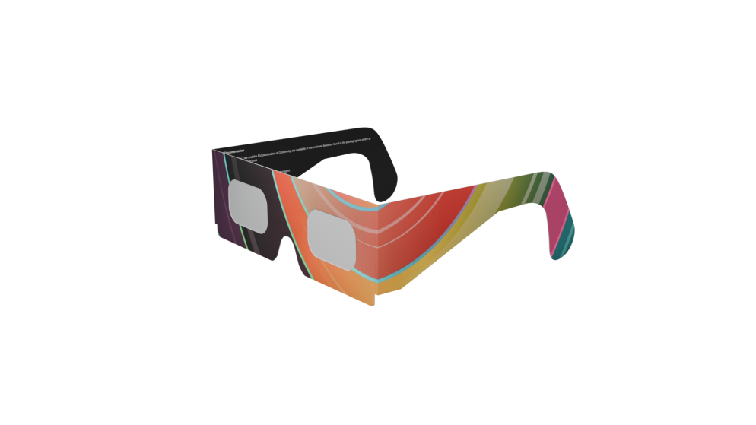
Solar Eclipse Glasses – Eclipse Pro Paper Series
Document Title: | Technical Drawing Package
Product | EclipsePro Paper Series
Document No.: | SEG-TDP-001
Revision: | B
Date: | 7/13/2028
Status: | FOR NOTIFIED BODY SUBMISSION

 |   Name | Signature | Date
Drawn By: | Māris Grāvītis |  | 7/13/2025
Checked By: | Māris Grāvītis |  | 7/13/2025
Approved By: | Māris Grāvītis |  | 7/13/2025

Table of Contents
Revision History 2
Assembly Drawing (SEG-ASSY-001) 3
Marking Specification (SEG-MRK-001) 4
Fabrication (SEG-FAB-001) 6
Fabrication (SEG-VAR-001) 7
Fabrication (SEG-FAB-002) 8

Revision History

Revision | Description Of Changes | Date | Approved By
A | Initial Release | 6/29/2025 | Māris Grāvītis
B | Changes to marking layout, and added dimensions to mandatory markings. | 7/12/2025 | Māris Grāvītis

Assembly Drawing (SEG-ASSY-001)
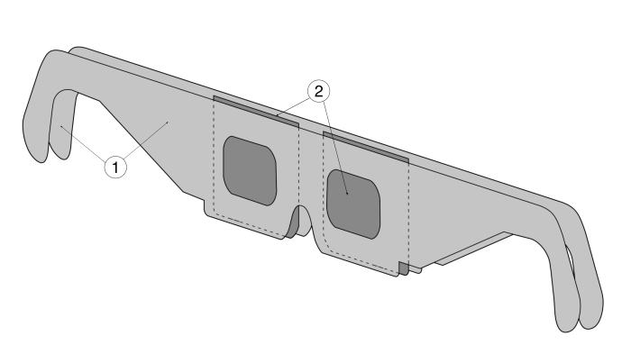  Item No. | Part Name / Description | Material Specification | Qty.
1. | Frame | Cardboard, NINGBO FOLD C1S, 250 g/m2 | 2
2. | Solar Filter Lens | Polymer Film, Certified to EN ISO 12312-2:2015 | 2s

NOTES:
THIS DRAWING ILLUSTRATES THE ASSEMBLY METHOD AND IS REPRESENTATIVE OF THE "BASE SHAPE" CONFIGURATION.
ACTUAL FRAME GEOMETRY IS DEFINED ON SPECIFIC FABRICATION DRAWINGS (E.G., SEG-FAB-001, ETC.).

Marking Specification (SEG-MRK-001)
The diagram below (Figure 1) shows the location of important markings. The table explains the meaning of each marking.
Ref. | Marking Description | Specification / Notes
A | Manufacturer & Origin | Location: Left temple arm.  Fulfills requirements of PPE Regulation (EU) 2016/425, Article 8(6). Graphic Component: Latvian Flag.  Text: “Manufactured by SIA GRAVITIS ENTERPRISE LIMITED, Lauku iela 7 – 4, Cēsis, LV-4101, Latvia” & “MADE IN LATVIA” with Latvian Flag of same height as text
B | Product Identification | Location: Below manufacturer information, on the right temple arm  Text: “EclipsePro Paper Series”
C |   Traceability Mark | Location: Center above nose bridge.  Unique Serial Number and corresponding Scratch-Off QR Code for online verification at verify.absoluteeclipse.com. Dimensions: 17.7x17.mm showing where the QR sticker shall be placed. Designed to be smaller than the QR sticker (20x20 mm)
D |   Warnings | Location: Right temple arm, left to ‘Important Safety…’ heading.  Fulfills mandatory warning requirements of EN ISO 12312-2:2015, Section 5.3 and PPE Regulation (EU) 2016/425, Annex II, §1.4. Must include the full, verbatim text: "Looking at the sun without proper eye protection causes permanent eye damage. Inspect for damage before each use. Do not use if damaged. Never use with optical instruments (e.g. binoculars). Use by children requires adult supervision." Minimum dimensions: 3.4x3mm
E |   Instructions & Declaration Of Conformity | Location: Right temple arm, left to ‘Instructions & Declaration…’ heading.  Compliance: Fulfills requirements of PPE Regulation (EU) 2016/425, Annex II, §1.4 (Instructions for Use) and Article 8(8) (access to Declaration of Conformity).  Content: Must include the full, verbatim text: "Online: Full Instructions & EU Declaration of Conformity  In Brochure: Printed Instructions for Use  View online documents at:  verify.absoluteeclipse.com/docs". Minimum dimensions: 3.4x2.5mm
F |   EU Origin Mark | Location: Bottom left corner of front frame.  “MADE IN EU” logo as shown, dimesions 8.5x8.5 mm
G |   ISO Standard Identification | Location: Tip of the left temple arm.  ISO 123212-2:2015 Standard, minimum height of: 7.1mm
H |   CE Mark | Location: Tip of the right temple arm.  Compliance: Declares conformity with PPE Regulation (EU) 2016/425. The graphic form and conditions for affixing are governed by Regulation (EC) 765/2008, Article 30.  Graphic: Must be the official CE logo, adhering to the proportions defined in the regulation's annex.  Size: Minimum height must be 5mm.
I | EU Conformity Statement | Declares conformity with Regulation (EU) 2016/425 (the PPE Regulation) and the harmonized standard EN ISO 12312-2:2015. This confirms the product is CE certified as Category II Personal Protective Equipment (PPE).  The text includes the mandatory details of the Notified Body that performed the EU Type-examination, a required step for Category II certification. This assessment was conducted by MTIC Intercert S.r.l. (Notified Body number 0068).  The full, verbatim text as shown must be used.

Figure 1: Location of markings on the frame front.
NOTES:
1. ALL MARKINGS SHOWN ARE MANDATORY AND MUST BE PRESENT ON EVERY UNIT SOLD.
2. MARKINGS MUST BE LEGIBLE AND PERMANENT.THIS DRAWING DEFINES THE CONTENT AND LOCATION OF REQUIRED MARKINGS ONLY.
3. DECORATIVE ARTWORK IS NOT CONTROLLED BY THIS DRAWING. OPTIONAL DECORATIVE ARTWORK IS PERMITTED. ALL SUCH ARTWORK MUST CONFORM TO THE SPECIFICATIONS AND CONTROLLING PRINCIPLES DEFINED IN TECHNICAL FILE TF-SG-ECL-001, SECTION [3.3].
4. UNLESS OTHERWISE SPECIFIED, ALL TEXT MARKINGS SHALL BE:
- FONT: Nimbus Sans L
- MINIMUM CAPITAL LETTER HEIGHT: 1.0mm
- COLOR: White
5. ALL MANDATORY MARKINGS (A-H) MUST BE RENDERED IN A COLOR THAT PROVIDES SUFFICIENT CONTRAST TO BE CLEARLY LEGIBLE. A MINIMUM CONTRAST RATIO OF 7:1 (WCAG AAA) IS RECOMMENDED.
6. NO DECORATIVE ARTWORK SHALL OBSCURE, OVERLAP, OR OTHERWISE IMPEDE THE LEGIBILITY OF ANY MANDATORY MARKING.

Fabrication (SEG-FAB-001)
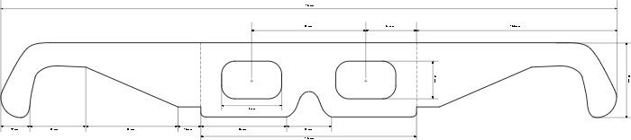

NOTES:
1. ALL DIMENSIONS ARE IN MILLIMETERS (mm).
2. DRAWING IS NOT TO SCALE (NTS).
3. FABRICATE TO DIMENSIONS SHOWN.
4. TOLERANCES, UNLESS OTHERWISE SPECIFIED:
LINEAR: ± 0.5 mm
ANGULAR: ± 1°
LINE TYPE LEGEND:
SOLID LINE (—): CUT PERIMETERDASHED
LINE (- - -): FOLD / CREASE LINE
5.REMOVE ALL BURRS AND SHARP EDGES AFTER CUTTING.

Fabrication (SEG-VAR-001)
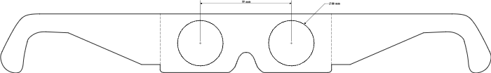
NOTES:
1. DRAWING IS NOT TO SCALE (NTS). FABRICATE TO DIMENSIONS SHOWN.
2. THIS DRAWING DEFINES THE DIMENSIONS FOR EYE HOLE VARIANT B. ONLY THE DIMENSIONS EXPLICITLY SHOWN ON THIS SHEET SUPERSEDE THOSE ON THE BASE DRAWING.
3. FOR ALL UNDIMENSIONED FEATURES, GEOMETRY, FOLD LINES, MATERIAL, AND TOLERANCES, REFER TO THE BASE FABRICATION DRAWING: SEG-FAB-001.

Fabrication (SEG-FAB-002)
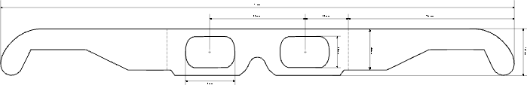

NOTES:
1. DRAWING IS NOT TO SCALE (NTS).
2. FABRICATE TO DIMENSIONS SHOWN.THIS DRAWING DEFINES THE OVERALL WIDTH AND PROFILE FOR THE "NARROW SHAPE" VARIANT. THE DIMENSIONS SHOWN ON THIS SHEET SUPERSEDE THE CORRESPONDING DIMENSIONS ON THE BASE DRAWING.
3. FOR ALL UNDIMENSIONED FEATURES (E.G., TEMPLE ARMS, FOLD LINES), GEOMETRY, MATERIAL, AND TOLERANCES, REFER TO THE BASE FABRICATION DRAWING: SEG-FAB-001.
4.DRAWING IS NOT TO SCALE (NTS). FABRICATE TO DIMENSIONS SHOWN.THIS DRAWING DEFINES THE OVERALL WIDTH AND PROFILE FOR THE "NARROW SHAPE" VARIANT. THE DIMENSIONS SHOWN ON THIS SHEET SUPERSEDE THE CORRESPONDING DIMENSIONS ON THE BASE DRAWING.

